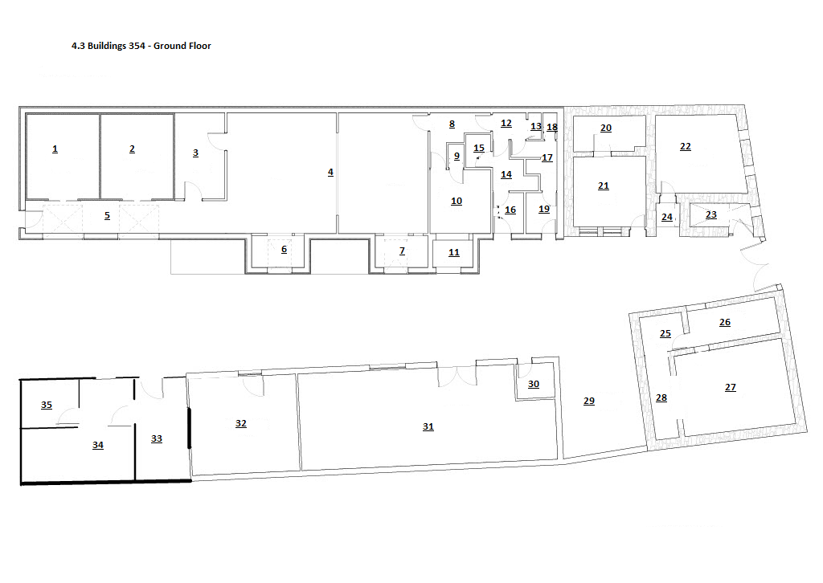

Nr. on Map | Name | Surface (m² )
1 | Cold Room 1 | 22.8
2 | Cold Room 2 | 22.8
3 | Finished Product Stock Room (jams, chuneys) | 16
4 | Production Facility | 81.2
5 | Corridor | 26
6 | Auxiliary Materials In | 6.7
7 | Raw Materials In | 6.7
8 | Hand wash corridor | 7.2
9 | Chemical store | 3
10 | Sugar Syrup Mixing Room | 15
11 | Sugar In | 4.3
12 | Filter Corridor | 3.27
13 | Cleaning utensils | 1.25
14 | Ladies filter room | 4.7
15 | Toilet | 3
16 | Ladies filter room | 4.7
17 | Gent’s filter room | 6.6
18 | Toilet | 1.36
19 | Gents filter room | 4.7
20 | Workshop | 9.2
21 | Central heating room | 19
22 | Shop | 23.4
23 | Shop stock | 2.7
24 | Shop entrance | 3.5
25 | Cellar entrance | 4
26 | Duty suspended store | 12.1
27 | Cellar stock (cordials, powder/wet ingredients) | 30
28 | Cellar corridor | 8.1
29 | Tasting area – summer | 31.75
30 | Allergen store | 5
31 | Sugar store | 78.8
32 | Auxiliary material store (jars, lids, bottles, caps) | 25.4
33 | Fermentation room | 17.36
34 | Distillation room | 24.8
35 | Alcohol stock room | 8.7

